**Name :**

**Roll no :**

**Group B Lab Assignment:** 10

**Subject :**PSDL

**Title :** PWM signal for DC/Servo motor on PIC18Fxxx

**Assignment No: 10**

**Title :** Embedded C program for generating PWM signal for DC/Servo motor on PIC18Fxxx.

**Aim :** To write a C program to interface PIC18F4550 to DC motor and varying speed using PWM signal generation.

**Experimental Setup:** MicroPIC18F board, USB cable, Power supply adaptor, DC motor, MPLABx IDE, PICLoader software.

**Objective:**

* To Perform interfacing of real-world input and output devices to PIC18FXXX microcontroller.
* To write and execute an Embedded C program to interface PIC18F4550 to DC motor and varying speed using PWM signal generation

**Theory:**

**1). DC motor speed and direction control with PIC18F4550**

DC motor converts electrical energy in the form of Direct Current into mechanical energy.

* In the case of the motor, the mechanical energy produced is in the form of a rotational movement of the motor shaft.
* The direction of rotation of the shaft of the motor can be reversed by reversing the direction of Direct Current through the motor.
* The motor can be rotated at a certain speed by applying a fixed voltage to it. If the voltage varies, the speed of the motor varies.
* Thus, the DC motor speed can be controlled by applying varying DC voltage; whereas the direction of rotation of the motor can be changed by reversing the direction of current through it.
* For applying varying voltage, we can make use of the PWM technique.
* For reversing the current, we can make use of H-Bridge circuit or motor driver ICs that employ the H-Bridge technique or other any other mechanisms**.**

The microcontroller PIC18F4550 has two CCP modules CCP1 and CCP2, the CCP1 module is implemented as a standard CCP module with Enhanced PWM capabilities. These include the provision for 2 or 4 output channels, user-selectable polarity, dead-band control and automatic. The Enhanced PWM mode provides additional PWM output options for a broader range of control applications. The module is a backward compatible version of the standard CCP module and offers up to four outputs, designated P1A through P1D. It is easy to control the speed of a DC motor using PIC18F4550 microcontroller since this microcontroller has a CCP module to generate a PWM signal, and by varying the duty cycle of the PWM signal the power delivered to the motor will also vary which causes the speed to change.

In Full-Bridge Output mode, four pins are used as outputs; however, only two outputs are active at a time. In the Forward mode, pin P1A is continuously active and pin P1D is modulated. In the Reverse mode, pin P1C is continuously active and pin P1B is modulated.

P1A, P1B, P1C and P1D outputs are multiplexed with the PORTC<2>, PORTD<5>, PORTD<6> and PORTD<7> data latches. The TRISC<2>, TRISD<5>, TRISD<6> and TRISD<7> bits must be cleared to make the P1A, P1B, P1C and P1D pins outputs.

The motor speed is controlled when the PWM duty cycle changes.

An H-Bridge circuit is used to reverse motor terminals which gives us the ability to change rotation direction

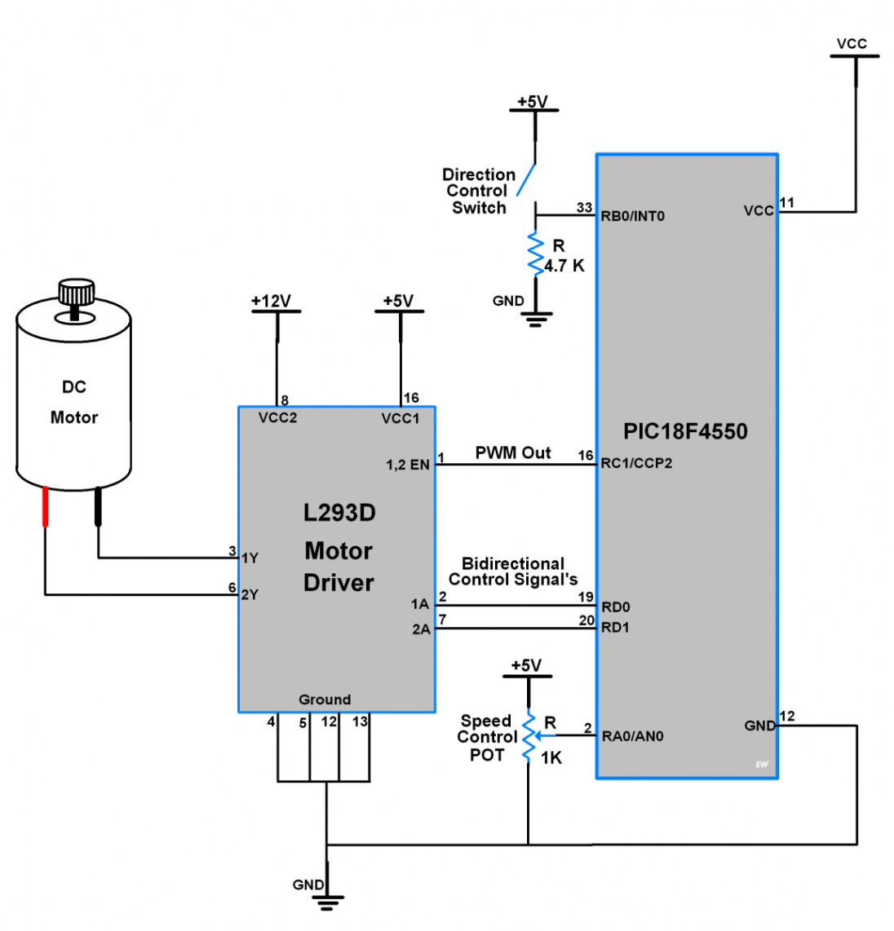

**PIC18F4550 Interface with DC Motor**.

**Procedure:**

**Step1:** Open MPLABX IDE on the PC for program development and create a new project and save it in a new folder.

**Step2:** Write the program in C language for interfacing DC motor to PIC18F4550 and varying speed using PWM . (in program properties make sure to add the 0x800 offset).

**Step3:** Build the program and create hex file. In case of errors correct program and rebuild to create hex file.

**Step4:** Prepare the experimental setup by connecting the MicroPIC18F board to the PC using USB cable. Power ON the Board. Check for the USBtoSerial COMx allocated by the PC**.**

**Step5:** Using the PICLoader Software flash the hex file in the PIC18F4550.

**Step6:** Press reset button and execute the program.

**.**

**Source code:**

/* Calculations

* Fosc = 48MHz

*

* PWM Period = [(PR2) + 1] * 4 * TMR2 Prescale Value / Fosc

* PWM Period = 200us

* TMR2 Prescale = 16

* Hence, PR2 = 149 or 0x95

*

* Duty Cycle = 10% of 200us

* Duty Cycle = 20us

* Duty Cycle = (CCPR1L:CCP1CON<5:4>) * TMR2 Prescale Value / Fosc

* CCP1CON<5:4> = <1:1>

* Hence, CCPR1L = 15 or 0x0F

*/

#include<p18f4550.h>

unsigned char count=0;

bit TIMER,SPEED_UP;

void timer2Init(void)

{

T2CON = 0b00000010; //Prescalar = 16; Timer2 OFF

PR2 = 0x95; //Period Register

}

void delay(unsigned int time)

{

unsigned int i,j;

for(i=0;i<time;i++)

for(j=0;j<1000;j++);

}

void main(void)

{

unsigned int i;

TRISCbits.TRISC1 = 0; //RC1 pin as output

TRISCbits.TRISC2 = 0; //CCP1 pin as output

LATCbits.LATC1 = 0;

CCP1CON = 0b00111100; //Select PWM mode; Duty cycle LSB CCP1CON<4:5> = <1:1>

CCPR1L = 0x0F; //Duty cycle 10%

timer2Init(); //Initialise Timer2

TMR2ON = 1; //Timer2 ON

while(1) //Loop forever

{

for(i=15;i<150;i++)

{

CCPR1L = i;

delay(100);

}

for(i=150;i>15;i--)

{

CCPR1L = i;

delay(100);

}

}

}

**Result:** Check if the DC motor speed varies.

**Conclusion:** Thus, we have studied embedded C programming for generating PWM signal for DC/Servo motor on PIC18Fxxx.